**AIML MINI PROJECT**

*GROUP MEMBERS: BATCH: A*

*SMRITHI AGRAWAL: 2019140001 CLASS; TE IT*

*KAREN CASTELINO: 2019140010 COURSE: AIML LAB*

**AIM:** To detect various diseases in a person using various machine learning models.

**GITHUB LINK:** <https://github.com/smrithi1912/AIML>

**PROBLEM STATEMENT:**

In today’s time we see a lot of the shortage of doctors in the world especially in India. A lot of people are suffering without a proper medical checkup. Also, most of the cases that arise lead to death due to lack of timely medical attention. So, to cope up with all of those problems, we have designed this web application that predicts if a person suffers from a particular disease or not using Machine Learning

**APPLICATIONS**:

* To remove the dependencies on the doctors
* To help out the poor and helpless people with the normal medical checkup
* To help people avoid paying huge amount to the doctors unnecessarily
* To extend the role of the technology in the medical field

**ALGORITHMS USED**:

1. Logistic Regression

Logistic regression is a [statistical model](https://en.wikipedia.org/wiki/Statistical_model) that in its basic form uses a [logistic function](https://en.wikipedia.org/wiki/Logistic_function) to model a [binary](https://en.wikipedia.org/wiki/Binary_variable) [dependent variable](https://en.wikipedia.org/wiki/Dependent_variable), although many more complex [extensions](https://en.wikipedia.org/wiki/Logistic_regression#Extensions) exist. In [regression analysis](https://en.wikipedia.org/wiki/Regression_analysis), logistic regression[[1]](https://en.wikipedia.org/wiki/Logistic_regression#cite_note-1) (or logit regression) is [estimating](https://en.wikipedia.org/wiki/Estimation_theory) the parameters of a logistic model (a form of [binary regression](https://en.wikipedia.org/wiki/Binary_regression)). Mathematically, a binary logistic model has a dependent variable with two possible values, such as pass/fail which is represented by an [indicator variable](https://en.wikipedia.org/wiki/Indicator_variable), where the two values are labeled "0" and "1".

Model :

Output = 0 or 1

Hypothesis => Z = WX + B

hΘ(x) = sigmoid (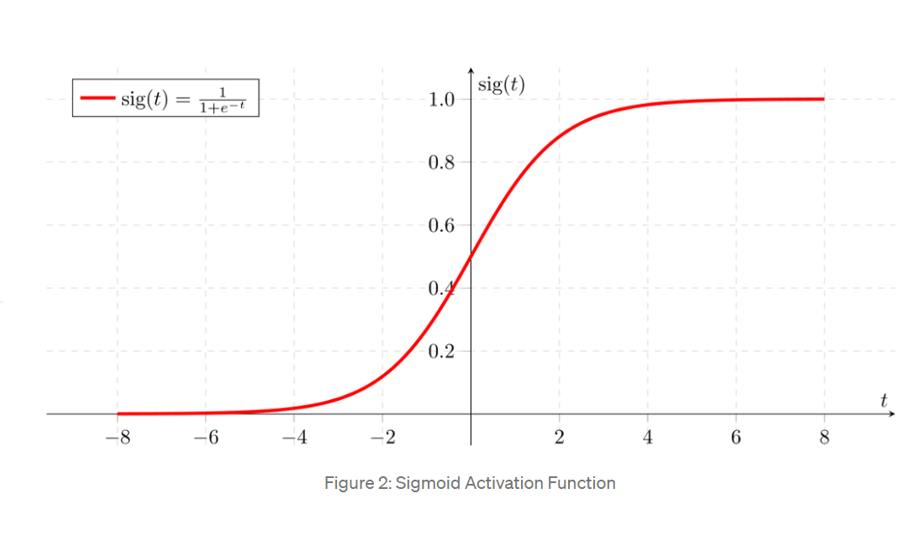Analysis of the hypothesis: The output from the hypothesis is the estimated probability. This is used to infer how confident can predicted value be actual value when given an input X. Consider the below example,

1. **Decision Tree Regressor**

Decision trees build regression or classification models in the form of a tree structure. It breaks down a dataset into smaller and smaller subsets while at the same time an associated decision tree is incrementally developed. The final result is a tree with decision nodes and leaf nodes. A decision tree is built top-down from a root node and involves partitioning the data into subsets that contain instances with similar values (homogenous). We use standard deviation to calculate the homogeneity of a numerical sample. If the numerical sample is completely homogeneous its standard deviation is zero.

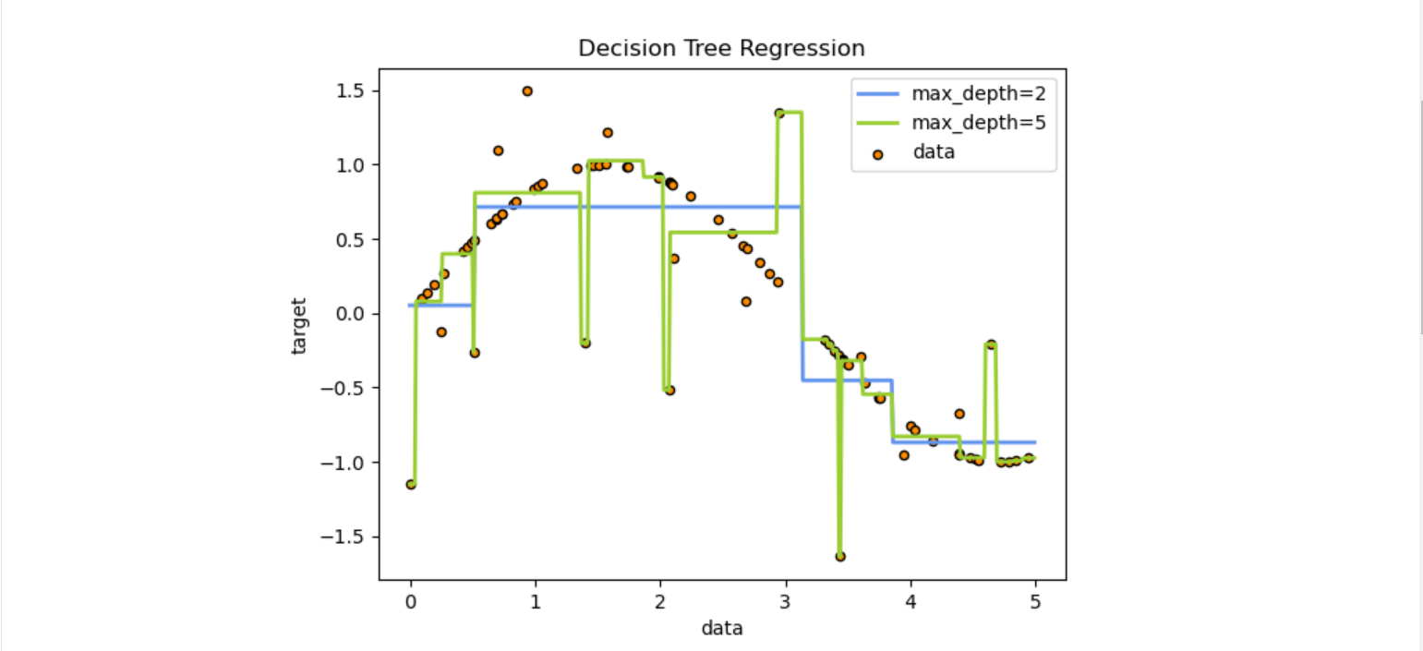

1. **Random Forest Regression**

Random Forest Regression is a supervised learning algorithm that uses ensemble learning method for regression. Ensemble learning method is a technique that combines predictions from multiple machine learning algorithms to make a more accurate prediction than a single model.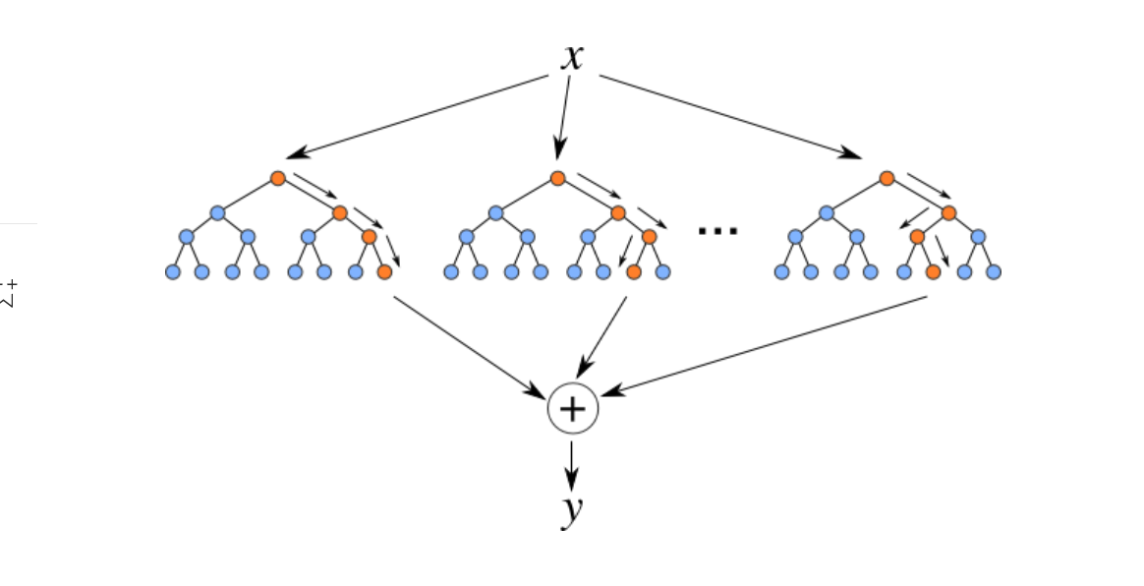

 A Random Forest operates by constructing several decision trees during training time and outputting the mean of the classes as the prediction of all the trees. To get a better understanding of the Random Forest algorithm, let’s walk through the steps:

1. Pick at random k data points from the training set.
2. Build a decision tree associated with these k data points.
3. Choose the number N of trees you want to build and repeat steps 1 and 2.
4. For a new data point, make each one of your N-tree trees predict the value of y for the data point in question and assign the new data point to the average across all of the predicted y values.

**MODEL FILES USED:**

Cancer Model = model

Diabetes Model = model1

Heart Model = model2

**DATASETS USED:**

[Drive Link](https://drive.google.com/drive/folders/1rhovgYjpjvcvQB-V9_UR6ylzi8isLKXj?usp=sharing)

Cancer =  cancer.csv

Diabetes = diabetes.csv

Heart = heart.csv

**TOOLS NEEDED**:

Python

Flask

TensorFlow

pillow

scikit

pandas

numpy

HTML  
CSS

**Colab File:**

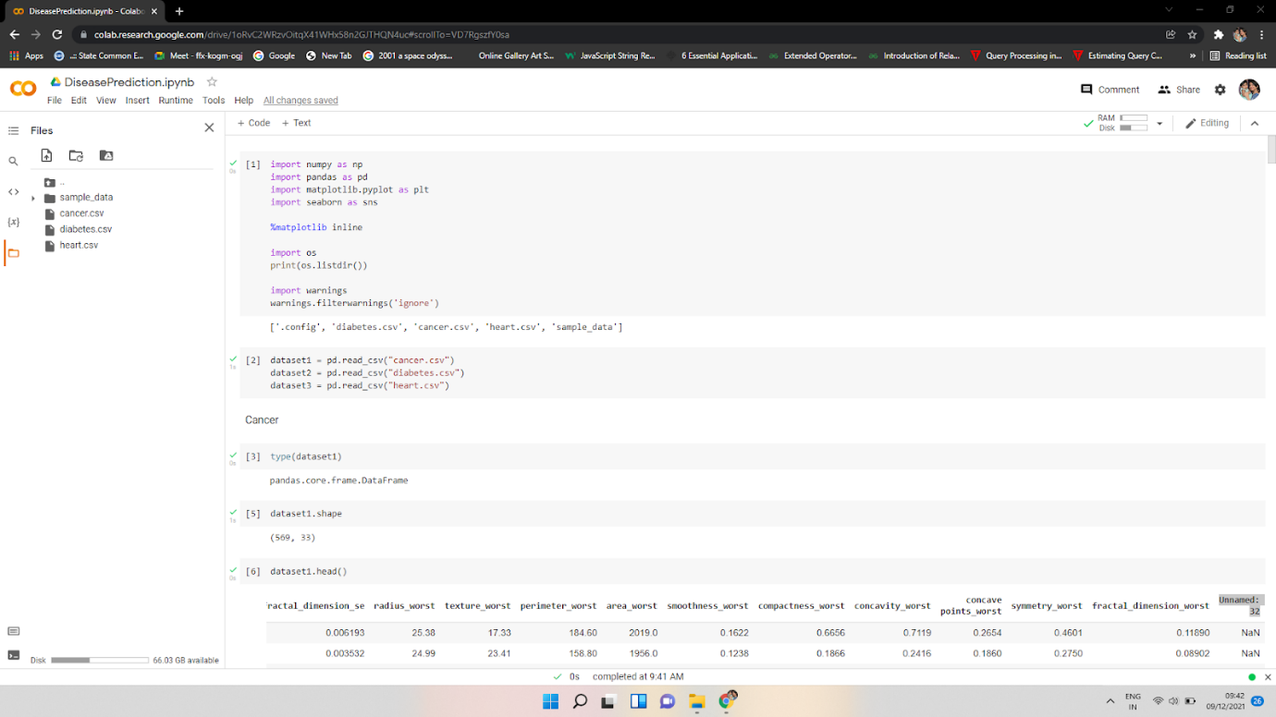

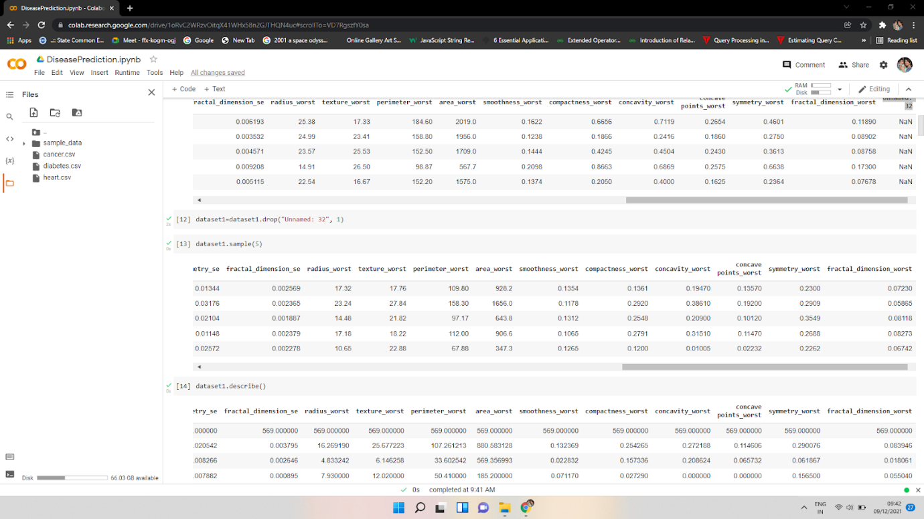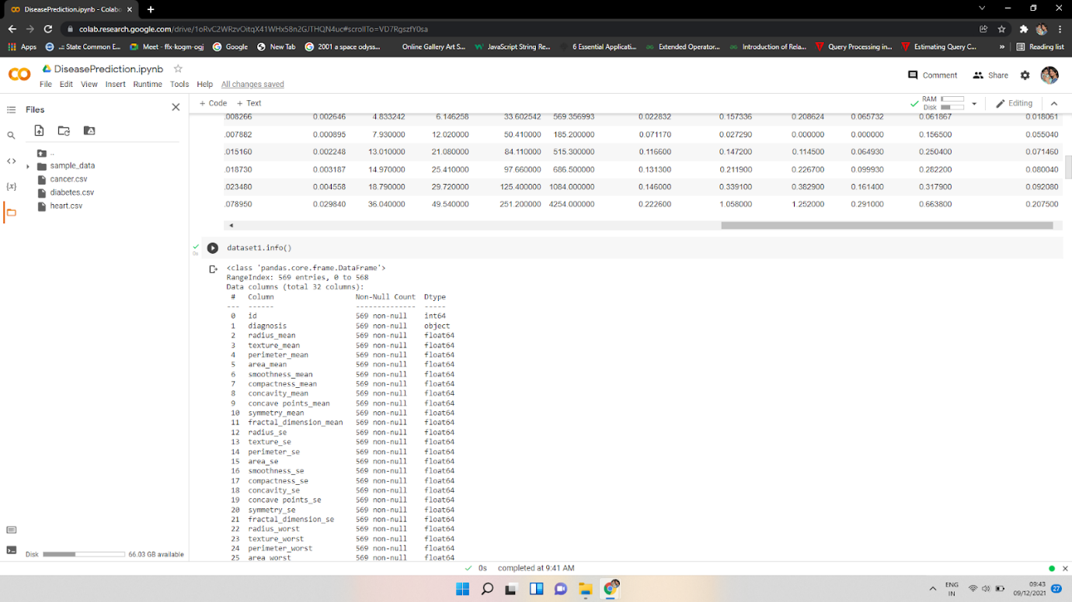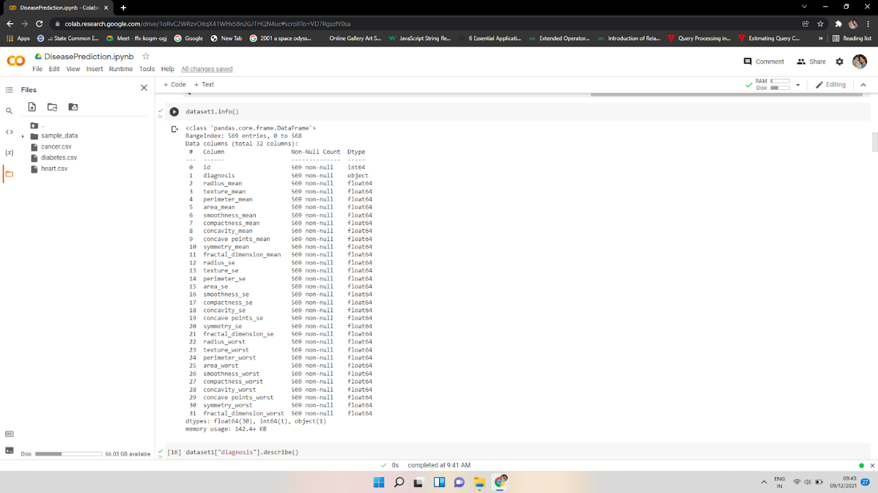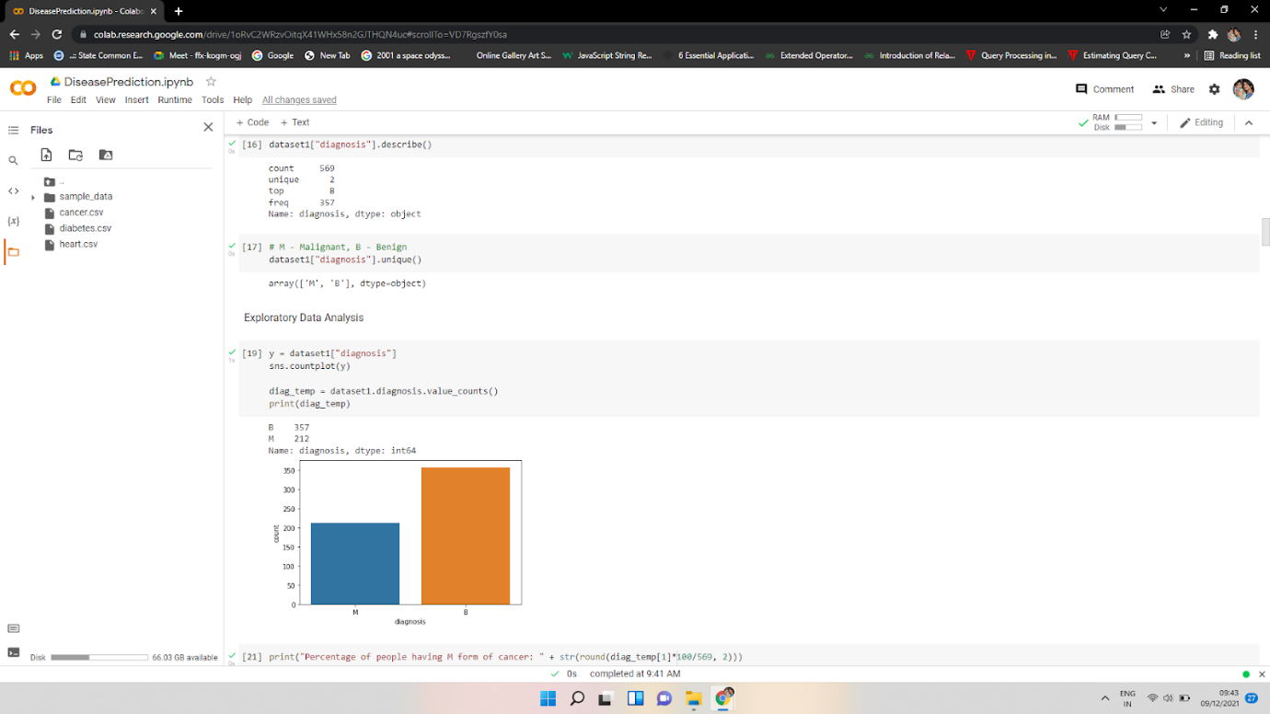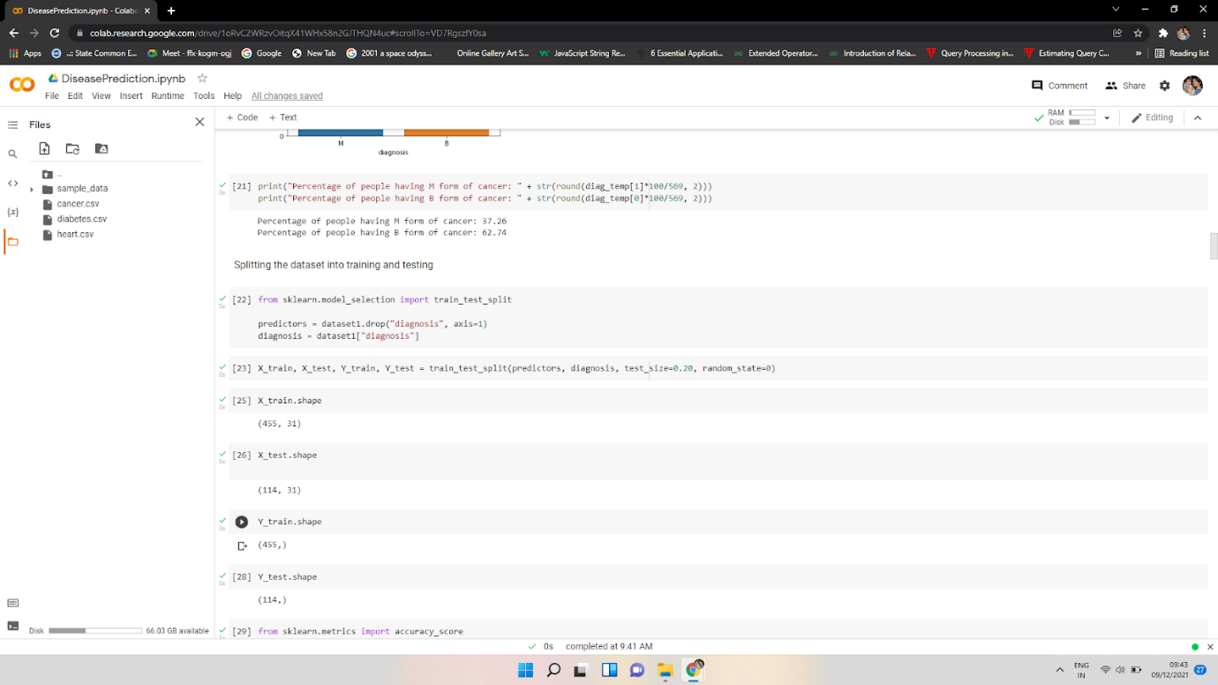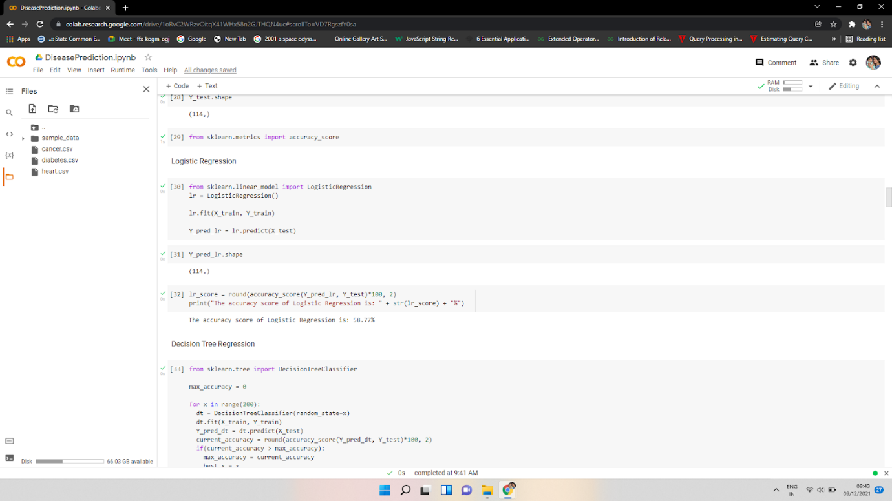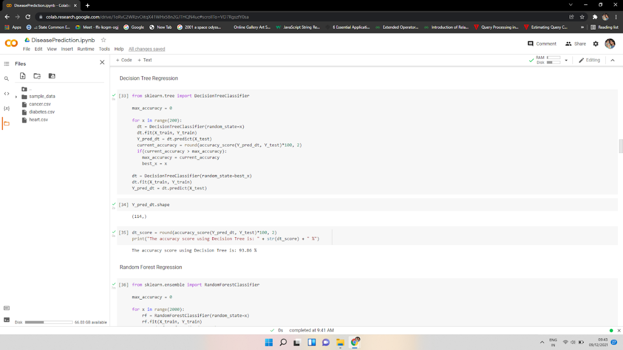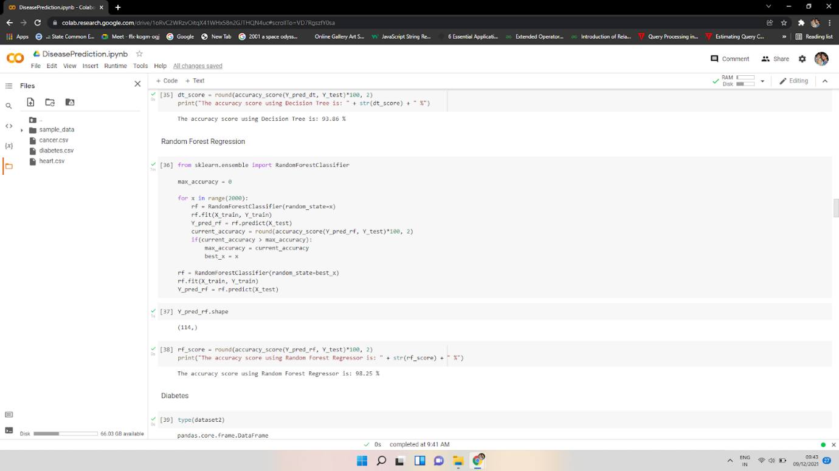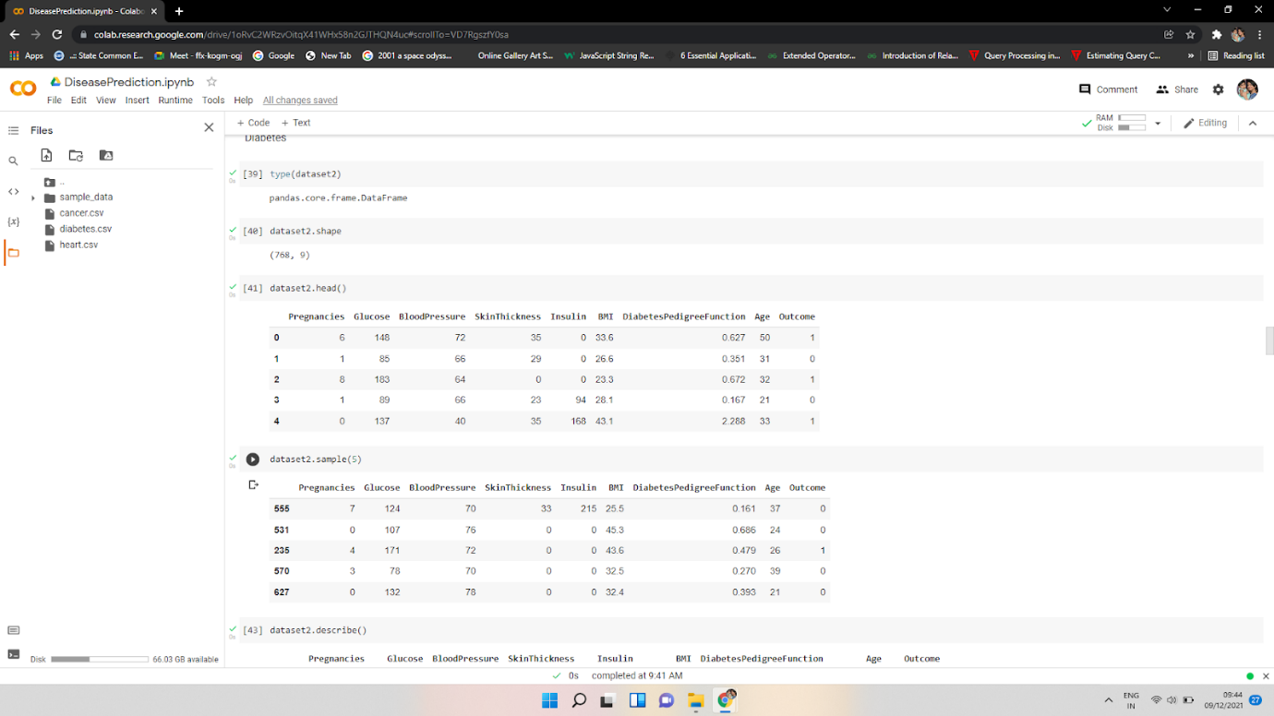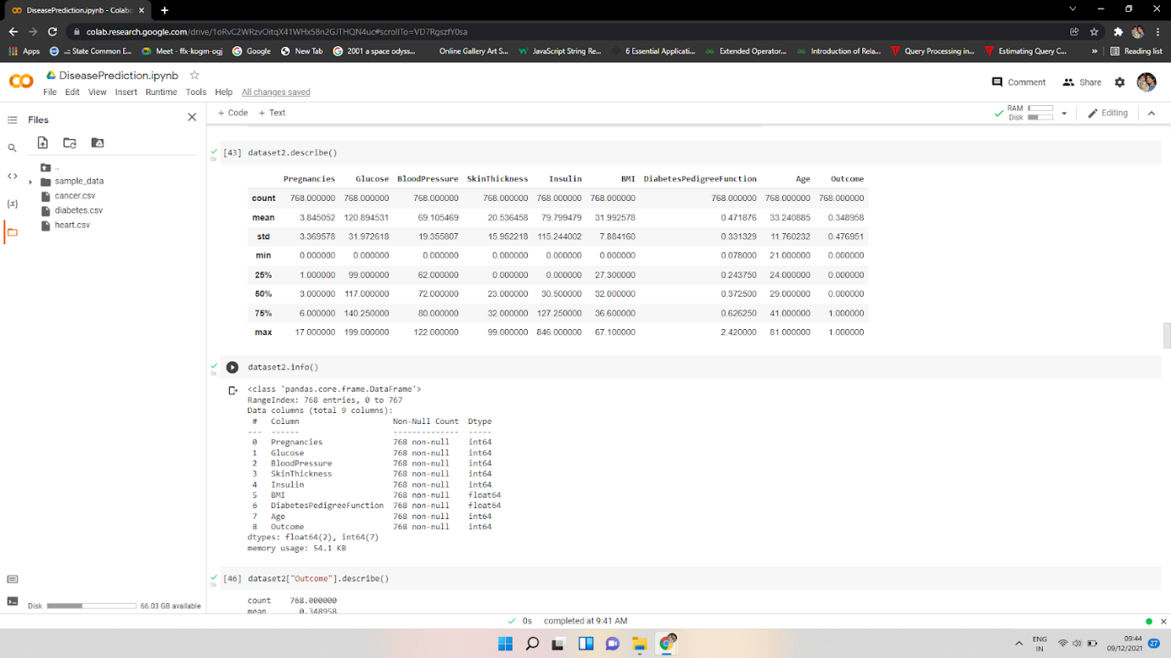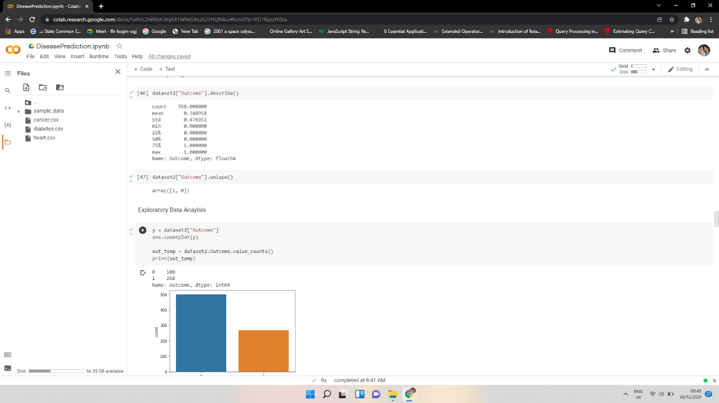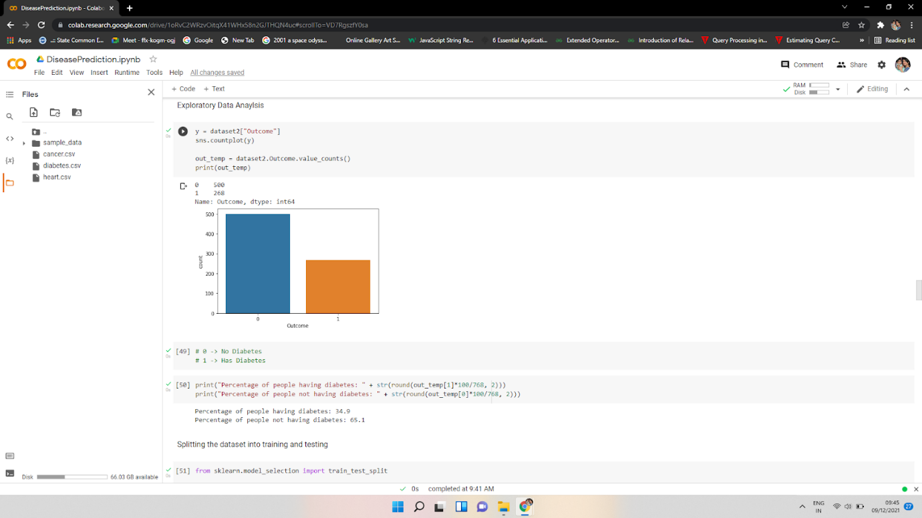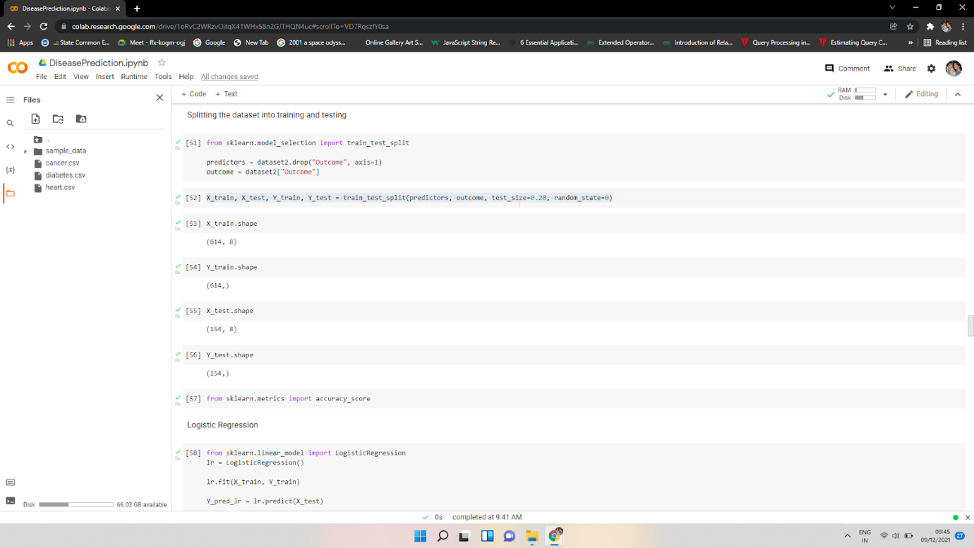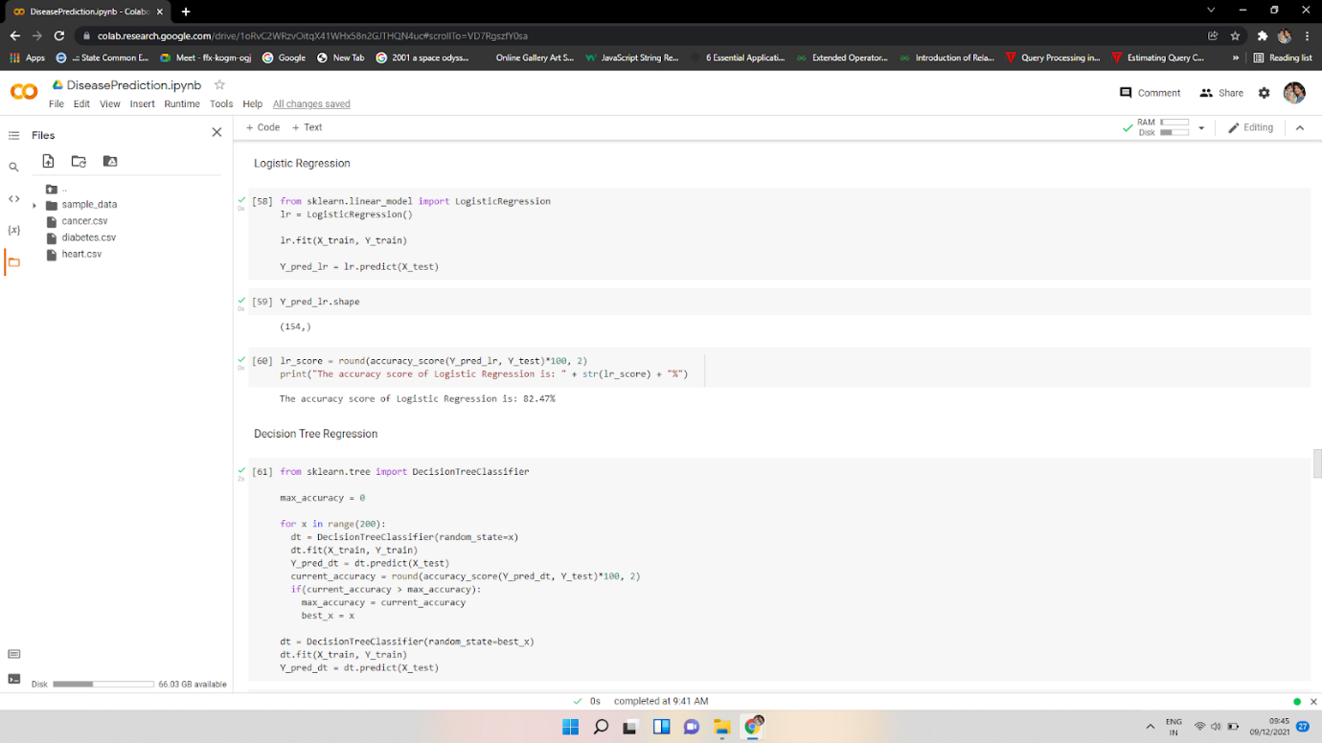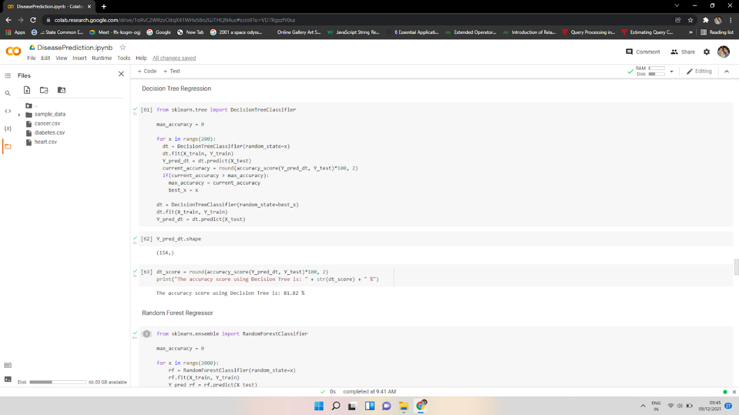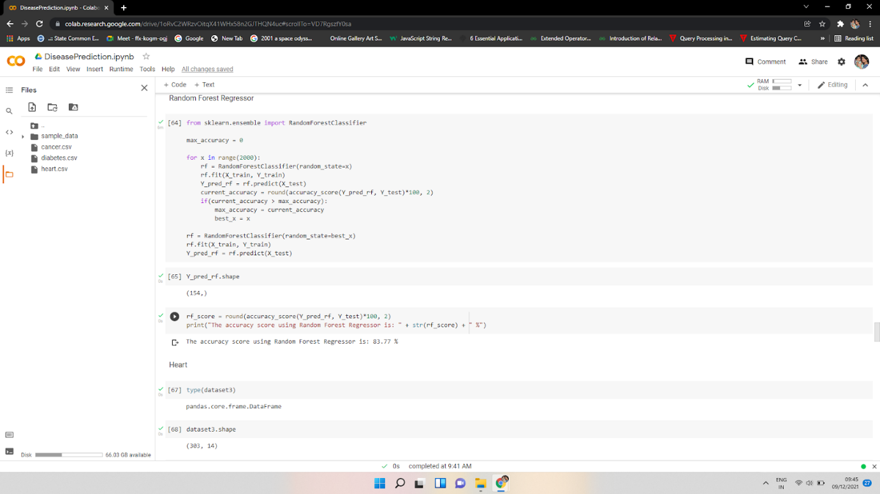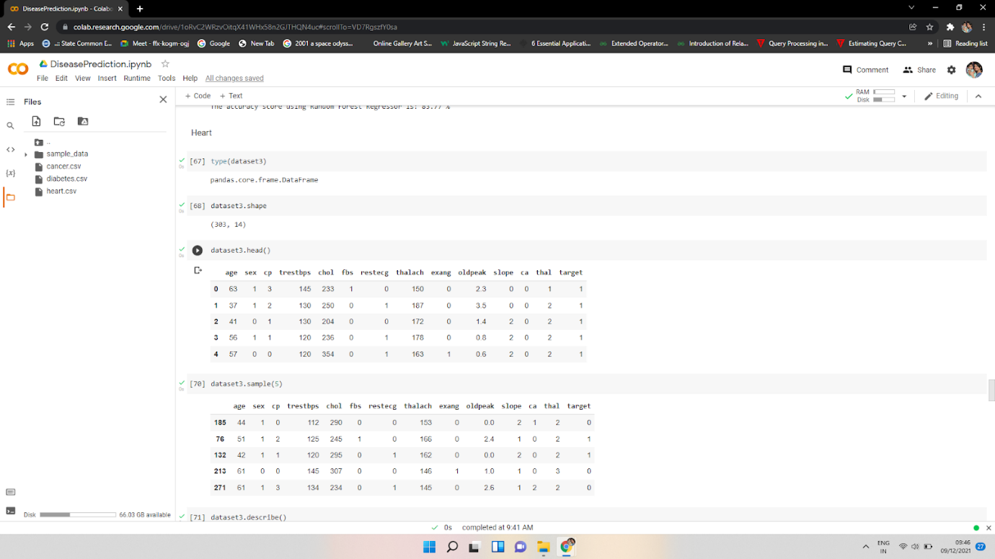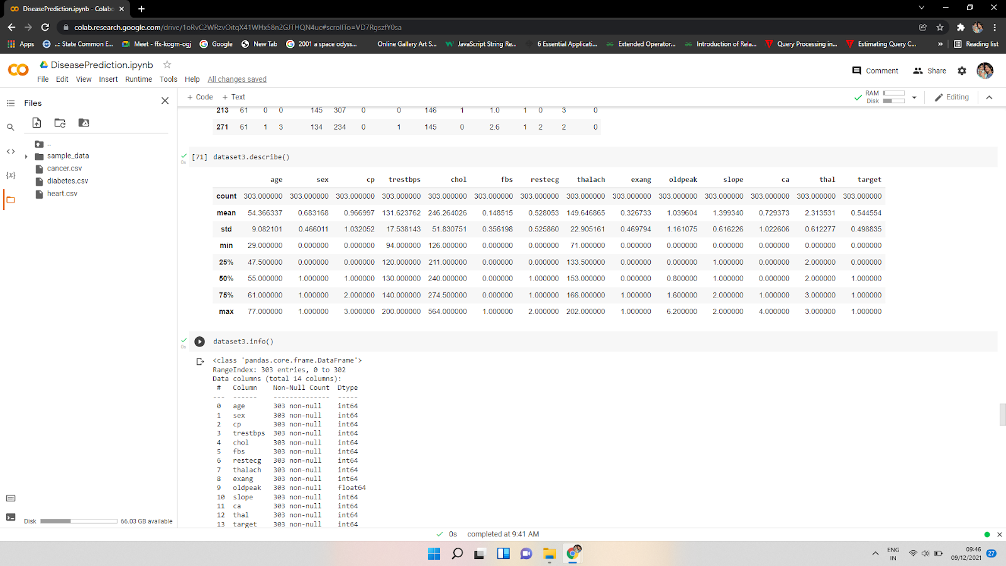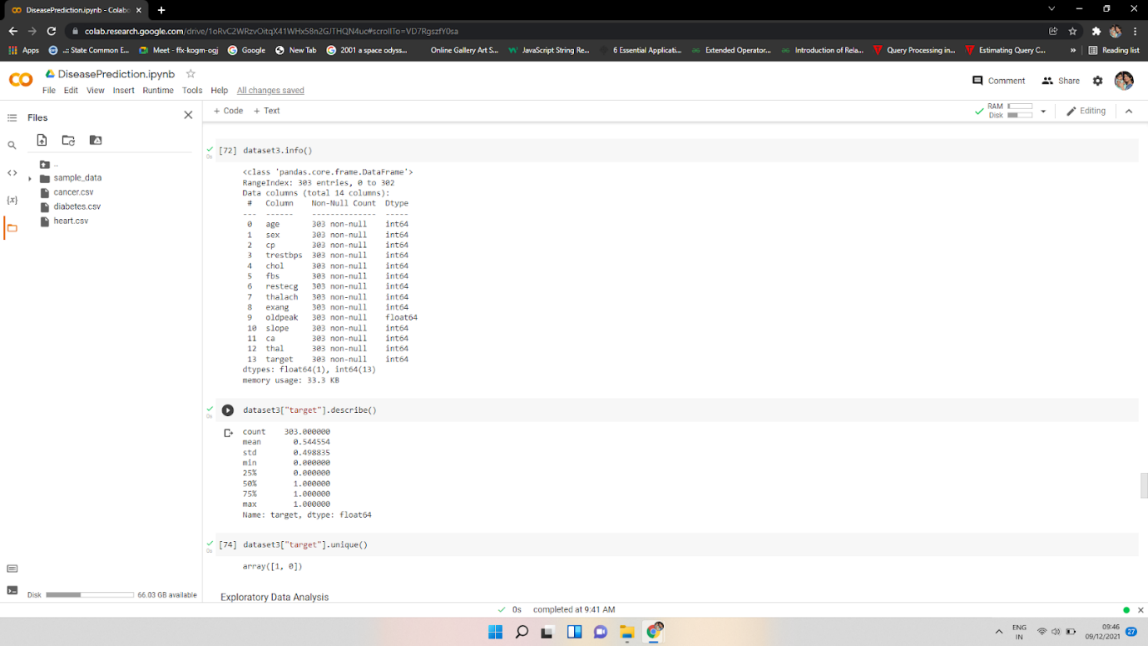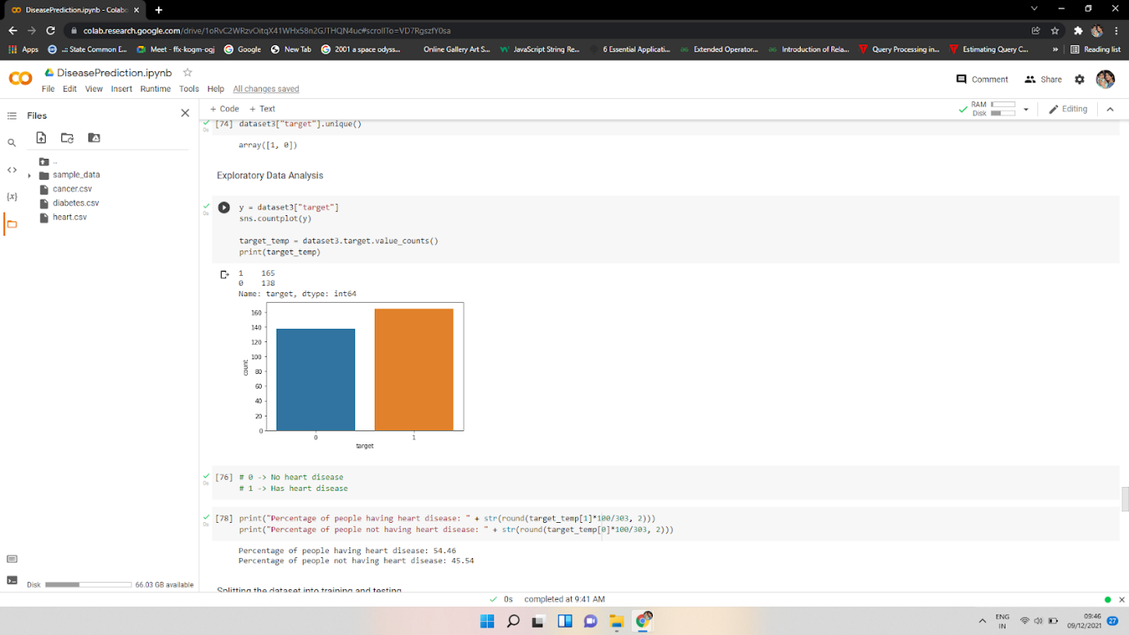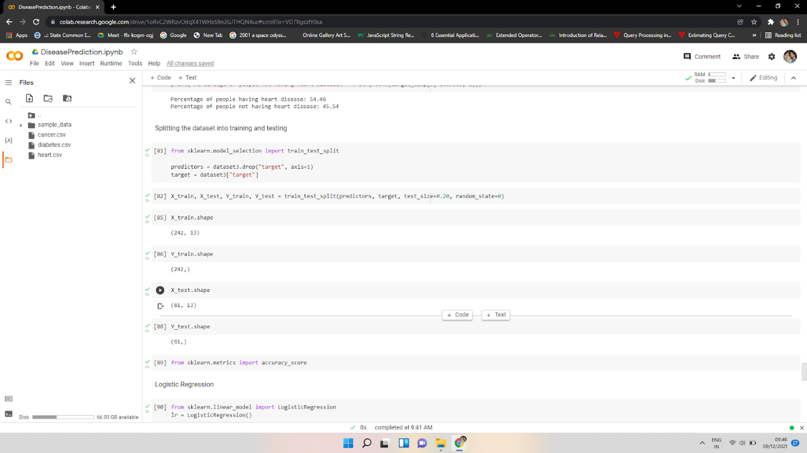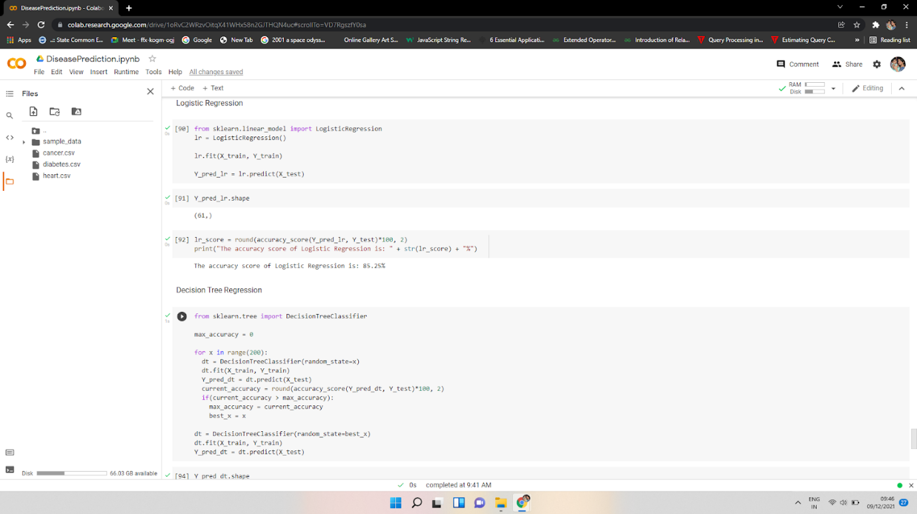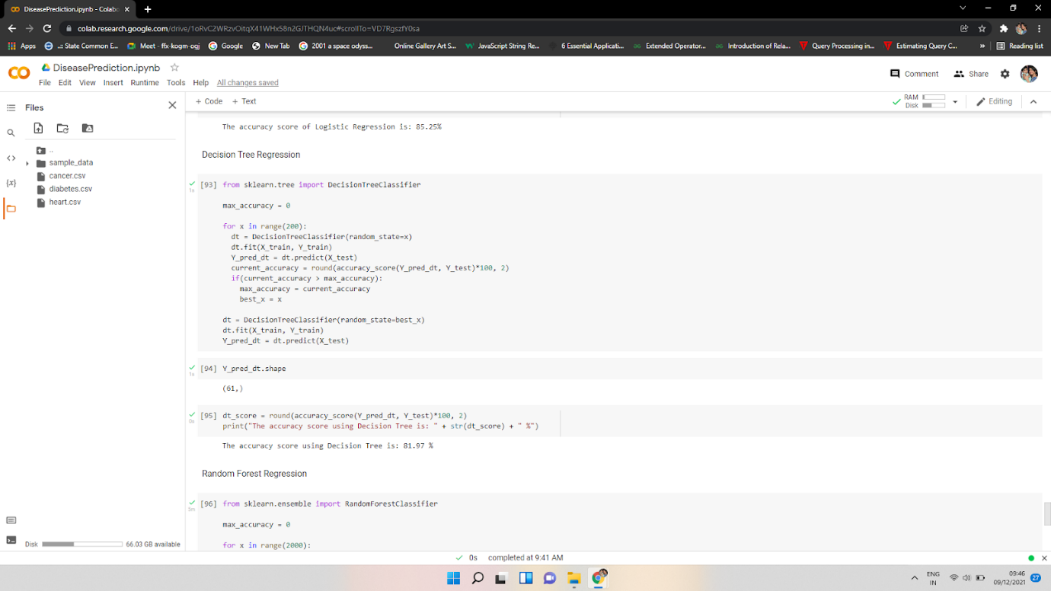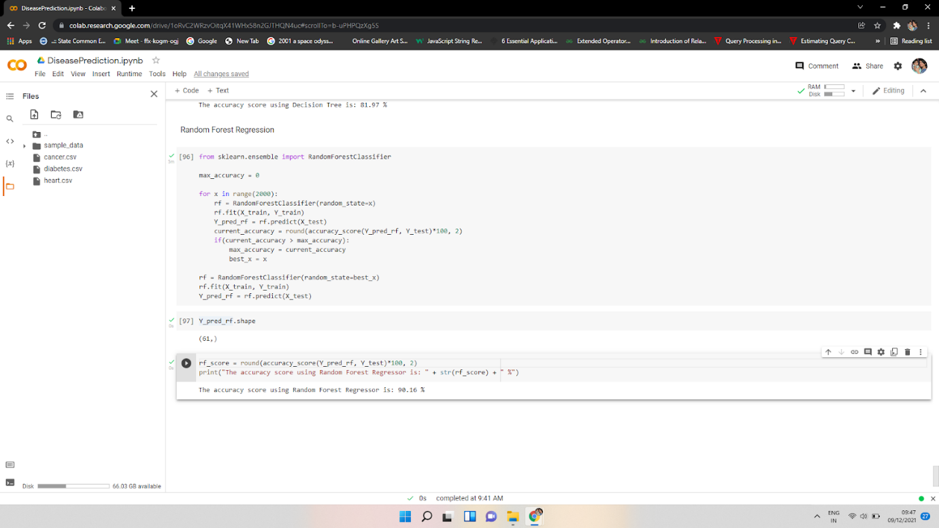

**Website Output:**

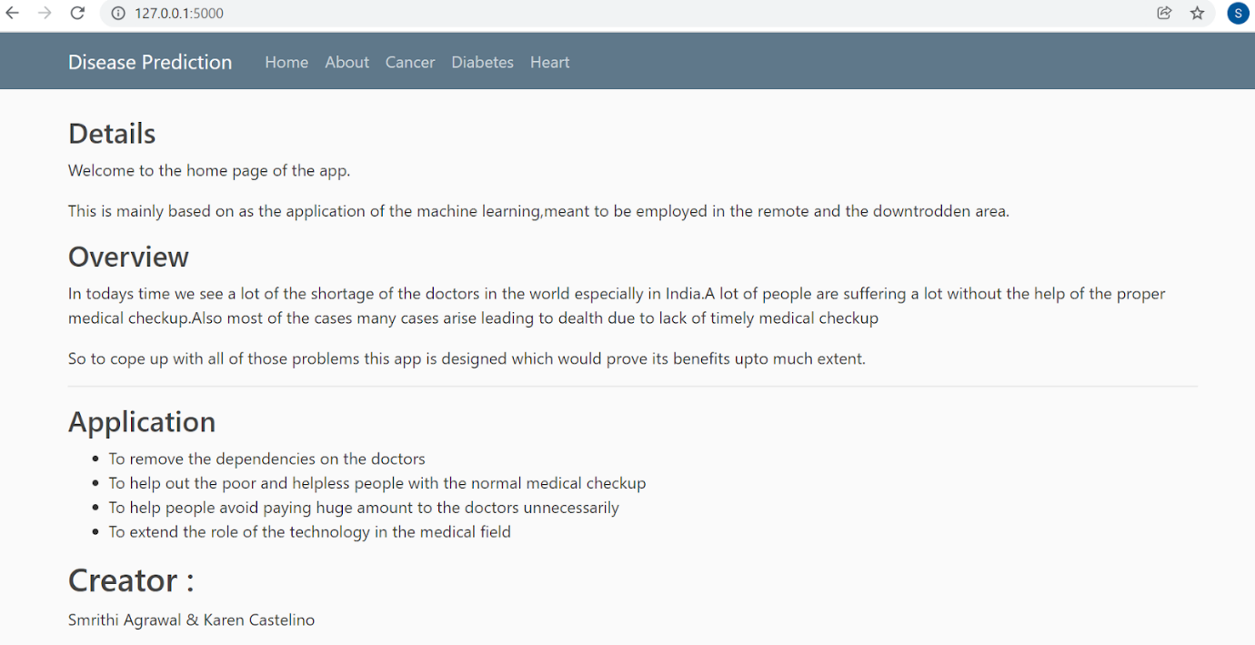

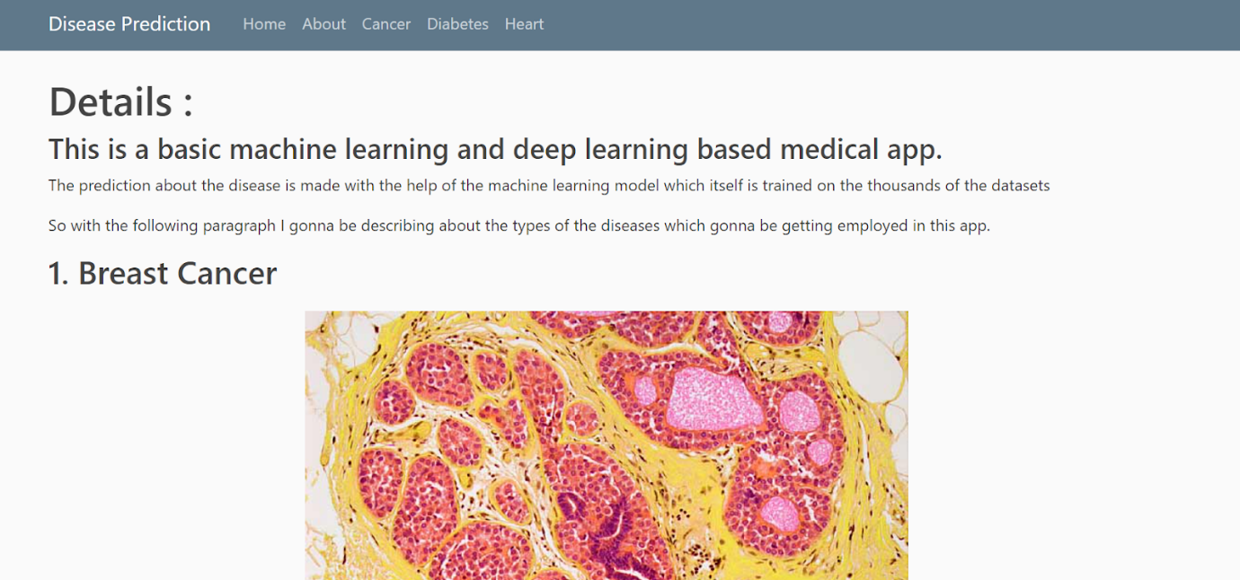

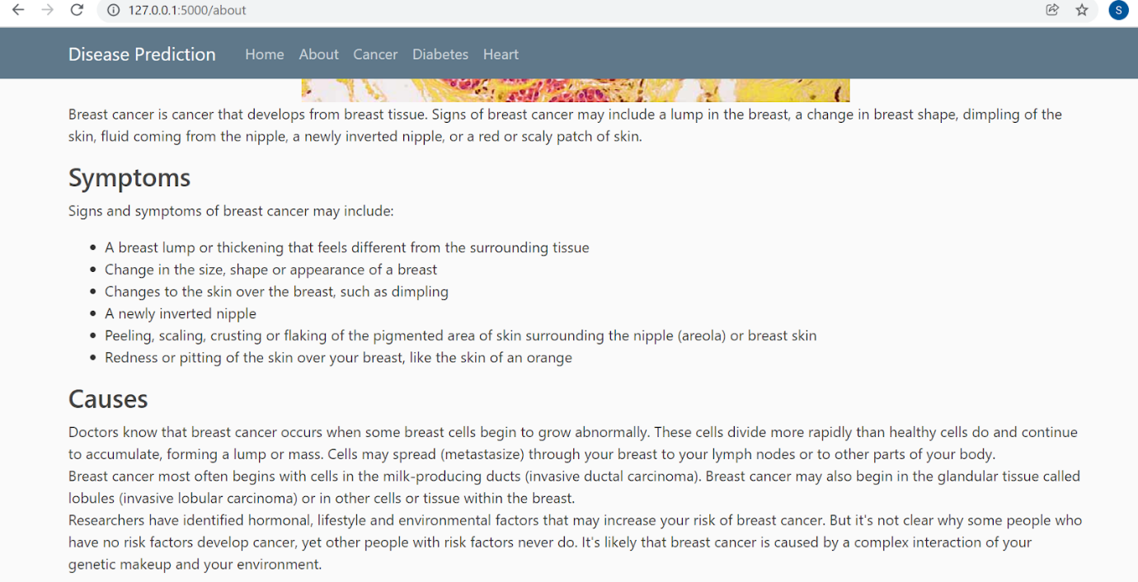

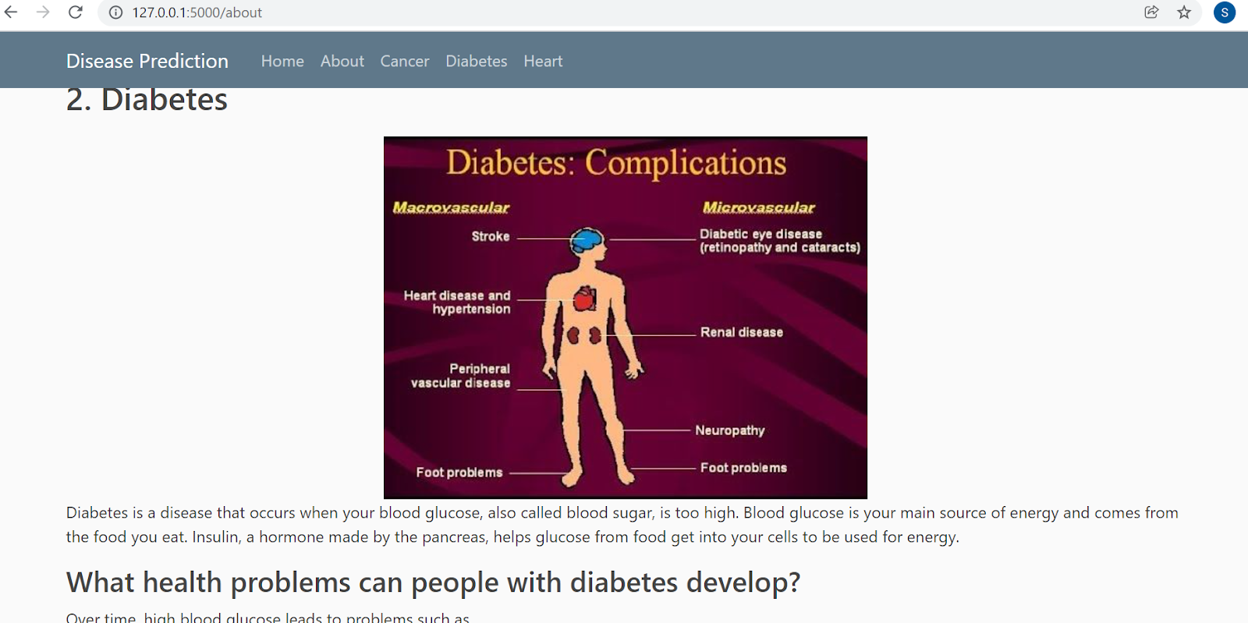

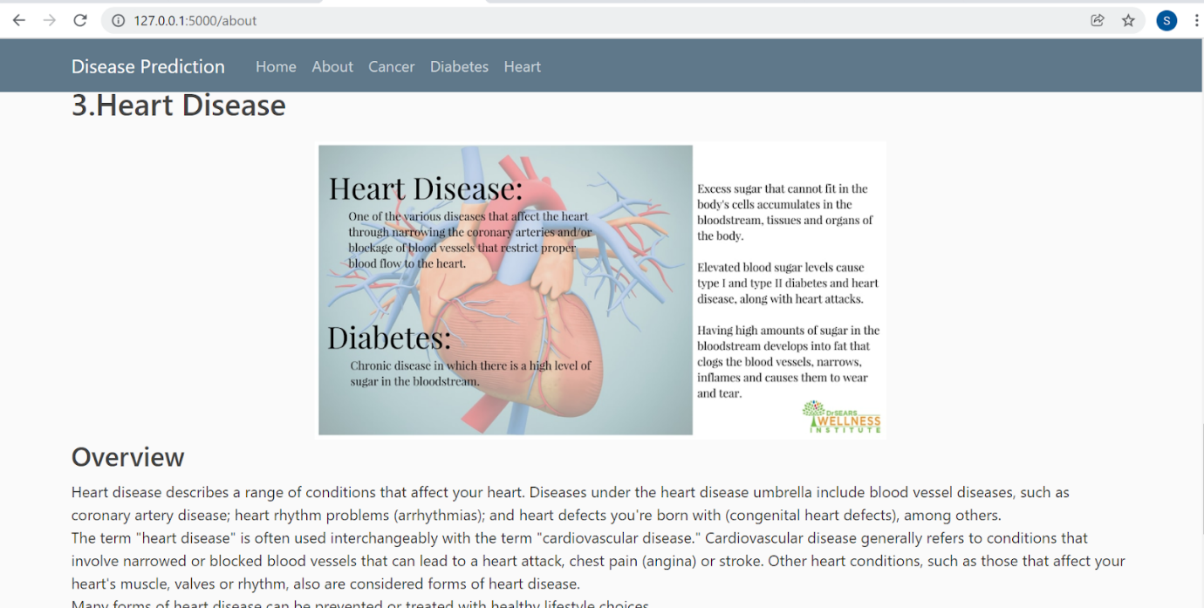

**Final Output:**

Cancer.html

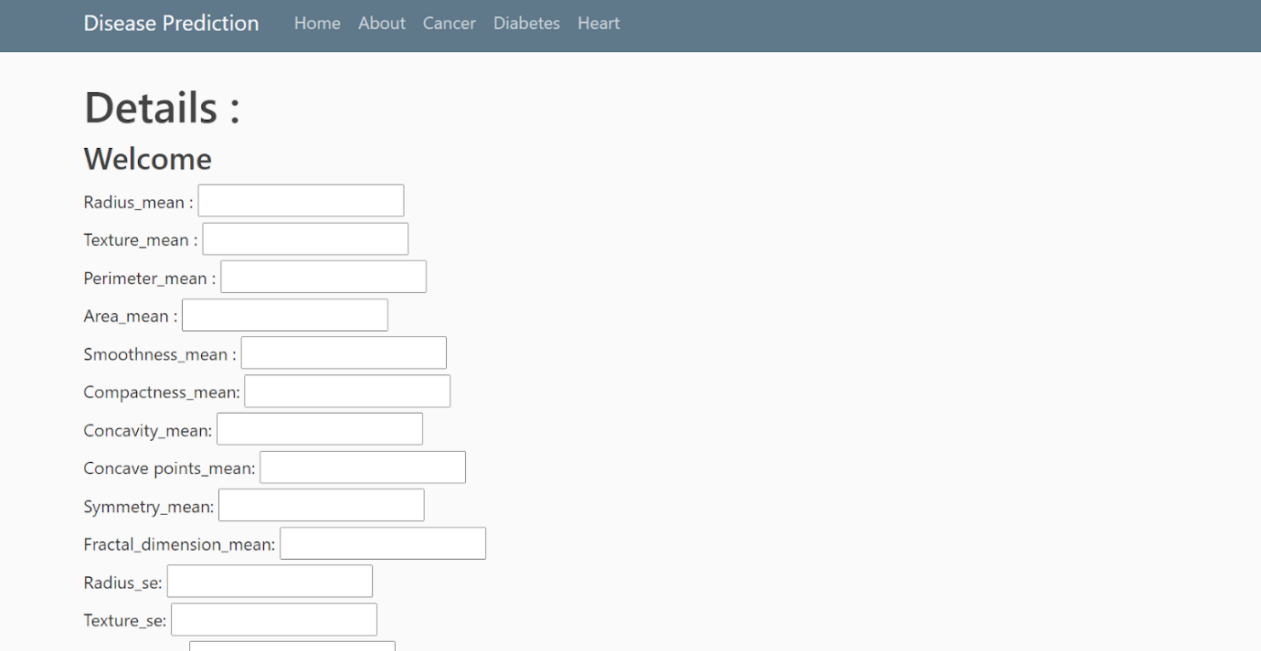

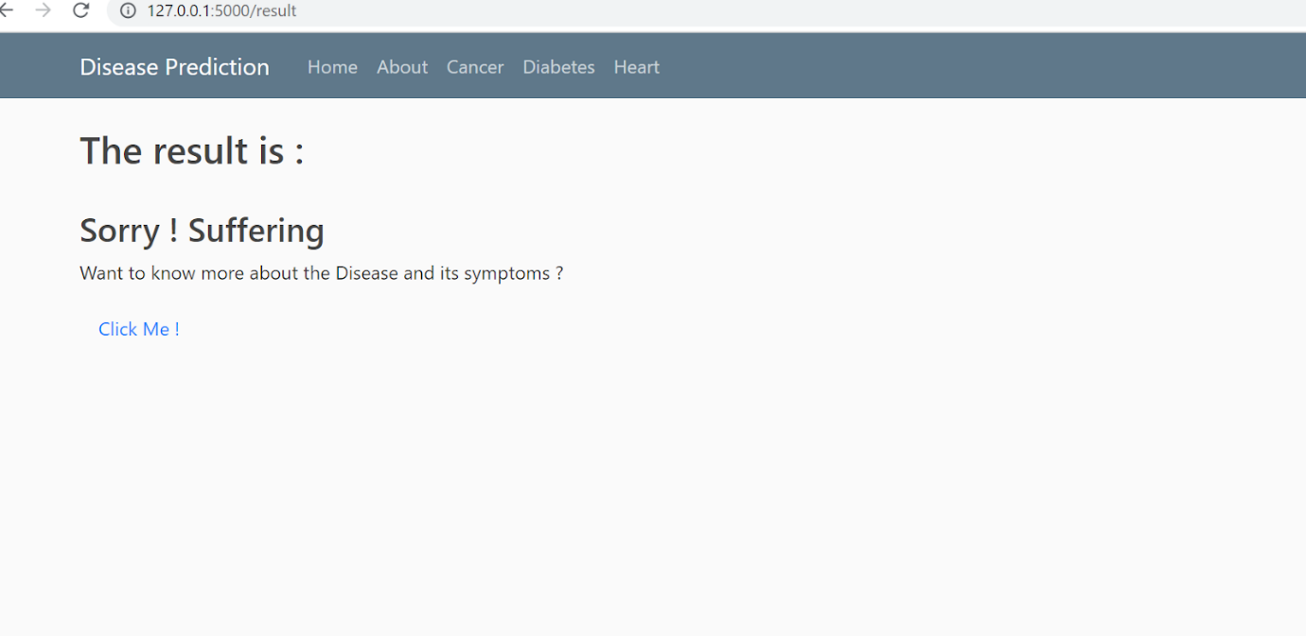

Diabetes.html

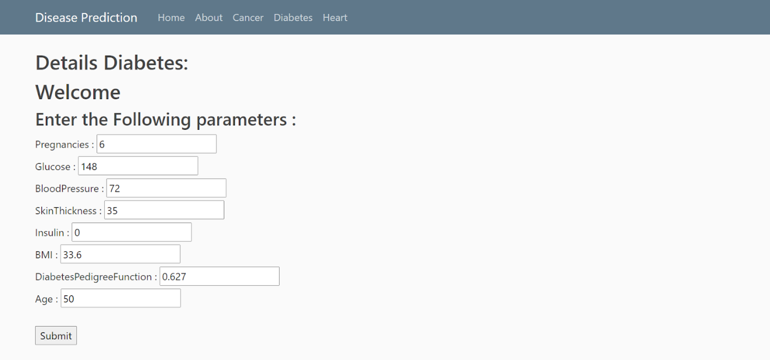

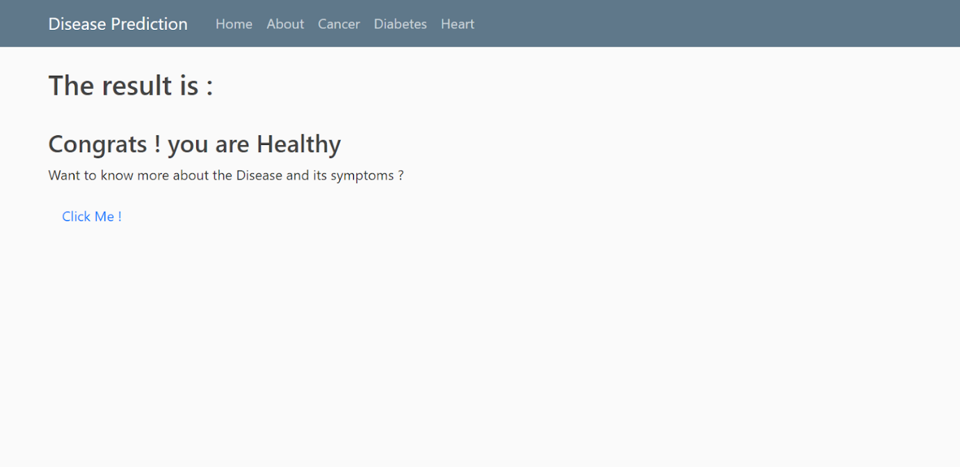

Heart.html

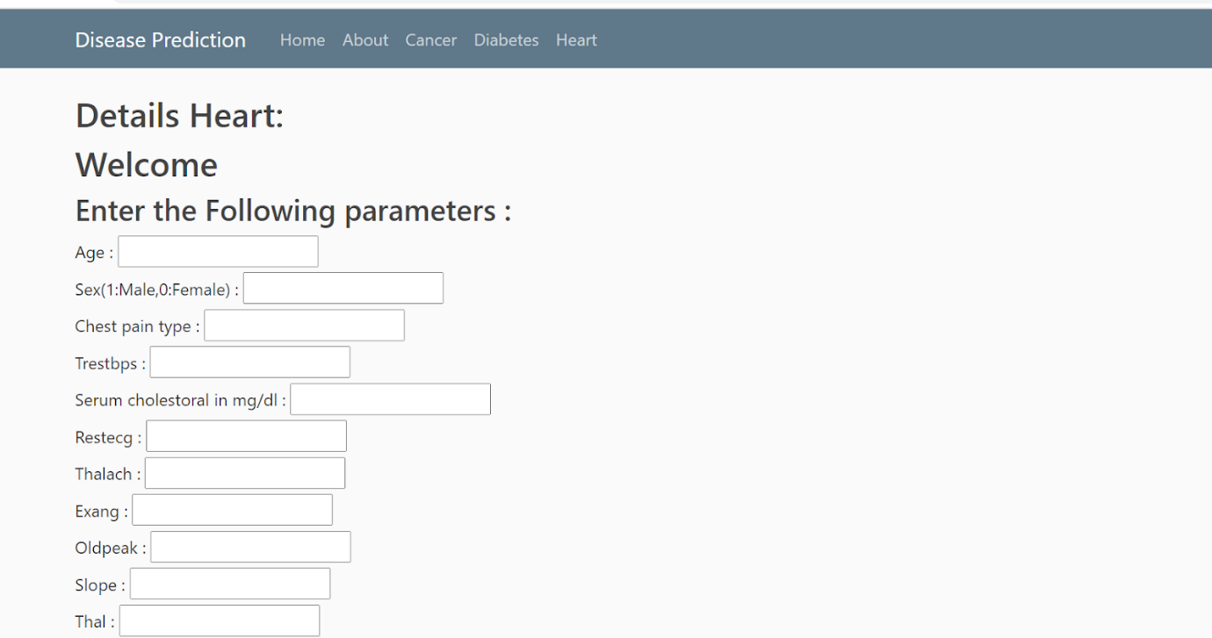

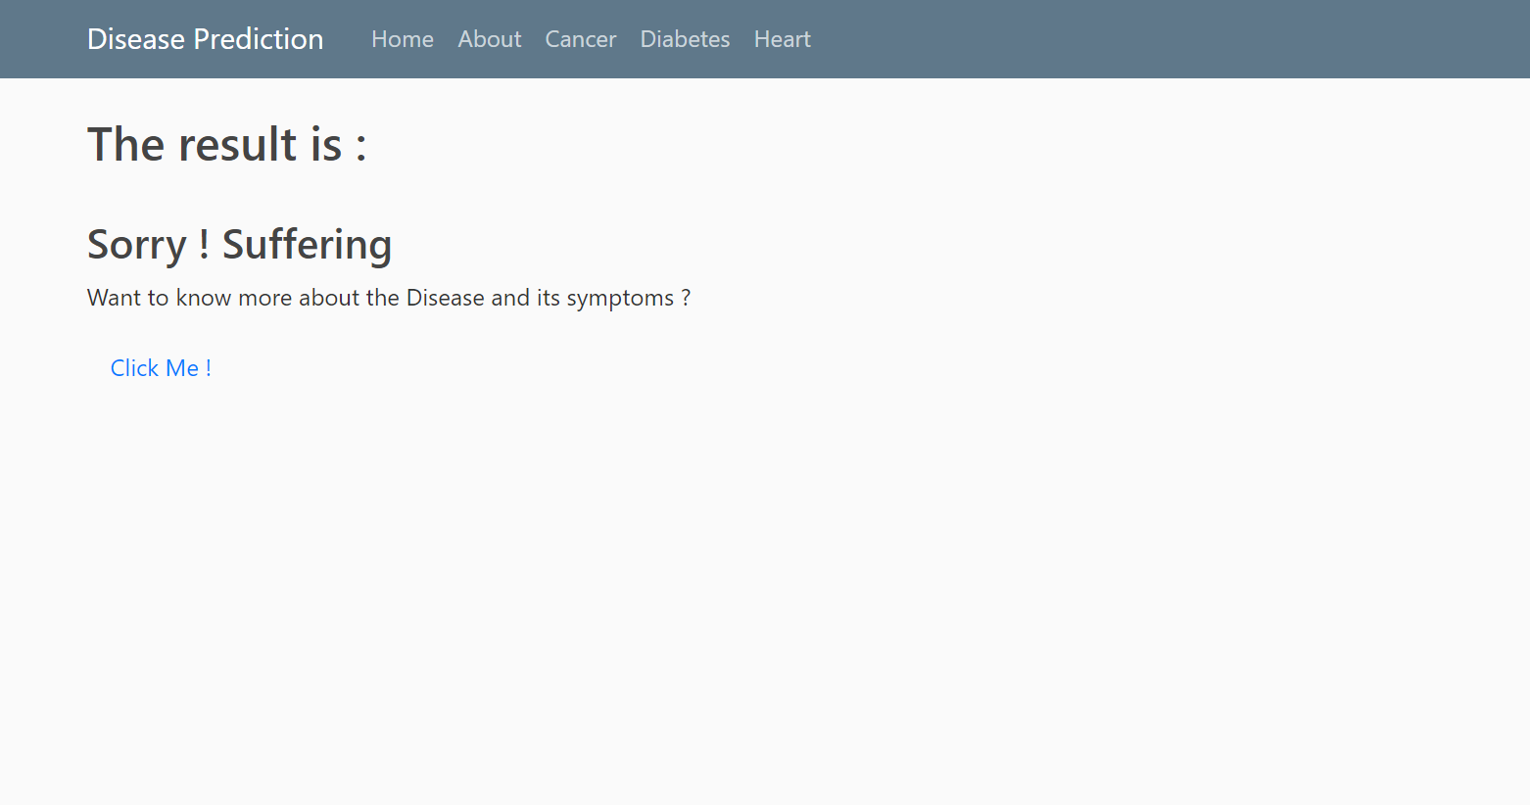

**Conclusion:**

The methods logistic regression, decision tree and random forest are analyzed for predicting the type of treatment that can be offered for the patient with cancer, diabetes or heart disease.

 The success rate of classification for cancer is 58.77% obtained by Logistic Regression. The accuracy using Decision Tree Regression is 93.86%. The prediction percentage using Random Forest Regression is 98.25%.

The success rate of classification for Diabetes is 82.47% obtained by Logistic Regression. The accuracy using Decision Tree Regression is 81.82%. The prediction percentage using Random Forest Regression is 83.77%.

The success rate of classification for Heart Disease is 85.25% obtained by Logistic Regression. The accuracy using Decision Tree regression is 81.97%. The prediction percentage using Random Forest Regression is 90.16%.

**Future Scope**

As a future enhancement, how the preprocessing of dataset can be improvised for increasing the success rate in classification and prediction process. Implementation of various other diseases can be done by the use of different algorithms to achieve better accuracy (most probably neural networks). An improved and user-friendly front-end can be useful for better accessibility to the website.

**Limitations**

* All the necessary input values must be present and accurate.
* The accuracy is not as good as we expect it to be, and sometimes this might result in a wrong prediction.
* The prediction might change after some time depending on the input attributes

**References:**

<https://www.geeksforgeeks.org/random-forest-regression-in-python/>

<https://ieeexplore.ieee.org/document/8455058>

<https://ieeexplore.ieee.org/document/9368899>

<https://www.sciencedirect.com/science/article/pii/S1319157820304134>